**VARUN KUMAR**

**2K19-IT-140**

**LAB – 9**

**Q1. Make an employee class; use dynamic allocation of memory to 6 objects/array of objects and**

**calculate the average of salaries of employees on same designation, assuming that there are 3**

**distinct designations and there are two employees serving on same designation. Overload binary ‘+’**

**using both member function and friend function.**

**Ie. (E1+E2)/2; use this expression to calculate average of salaries for a same designation.**

**#include<iostream>**

**#include<string>**

**using namespace std;**

**class Employee**

**{**

**string emp_number;**

**int salary;**

**string designation;**

**public:**

**Employee()**

**{**

**int t;**

**cout<<"Enter the employee number : ";**

**cin>>emp_number;**

**cout<<"Enter the salary : ";**

**cin>>salary;**

**cout<<"choose your designation : 1.Asst manager || 2.clerk || 3.vp"<<endl;**

**cin>>t;**

**switch (t)**

**{**

**case 1: designation="Asst manager";**

**break;**

**case 2: designation ="clerk";**

**break;**

**case 3: designation ="vp";**

**break;**

**default: designation ="none";**

**break;**

**}**

**}**

**int get_salary()**

**{ return this->salary; }**

**string get_designation()**

**{ return this->designation; }**

**int operator + (Employee const &e1) // operator overloading**

**{**

**return (this->salary + e1.salary);**

**}**

**};**

**void average_salary(Employee e1, Employee e2) // use of operator overloading**

**{**

**cout<<"\nAvg salary for "<<e1.get_designation()<<" is "<<(e1+e2)/2;**

**}**

**int main()**

**{**

**Employee * E = new Employee[6];**

**for (int i = 0; i < 6; i++)**

**{**

**E[i];**

**}**

**for (int i = 0; i < 5; i=i+2)**

**{**

**average_salary(E[i],E[i+1]); // displaying the avg salary**

**}**

**return 0;**

**}**

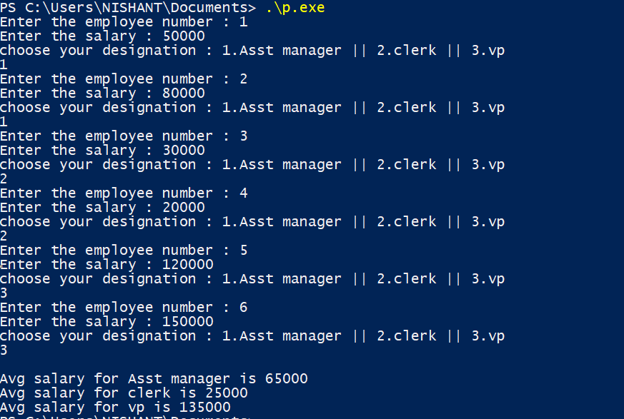

**Q2. Use function overloading with class student for function Make_project().**

**Make_project(): for 1st year students**

**Make_project(one argument): 2nd year student and so on...... till final year students.**

**#include<iostream>**

**#include<string>**

**using namespace std;**

**class Student**

**{**

**string name;**

**public:**

**Student()**

**: name{"deafult name"}**

**{}**

**Student(string name_val)**

**: name{name_val}**

**{}**

**void make_project()**

**{**

**cout<<"\nThis 1st year project is done by "<<this->name<<endl;**

**}**

**void make_project(float year1) // cg for first year**

**{**

**cout<<"\nThis 2nd year project is done by "<<this->name<<endl;**

**}**

**void make_project(float year1, float year2) // cg for 1st and 2nd year**

**{**

**cout<<"\nThis 3rd year project is done by "<<this->name<<endl;**

**}**

**void make_project(float year1, float year2, float year3) // cg for all the 3 years**

**{**

**cout<<"\nThis 4th year project is done by "<<this->name<<endl;**

**}**

**};**

**int main()**

**{**

**Student s1("VARUN");**

**Student s2("VANSH");**

**Student s3("JAI");**

**Student s4("KUNAL");**

**s1.make_project();**

**s2.make_project(9.5);**

**s3.make_project(8.6,8.0);**

**s4.make_project(7.8,9.8,9.2);**

**}**

